Indian School Al Wadi Al Kabir
SAMPLE PAPER 5(2023-24)
INFORMATICS PRACTICES (Code: 065)
CLASS : XII Max. Marks:70
Time: 3 hours.

General Instructions:
- This question paper contains five sections, Section A to E.
- All questions are compulsory.
- Section A has 18 questions carrying 01 mark each.
- Section B has 07 Very Short Answer type questions carrying 02 marks each.
- Section C has 05 Short Answer type questions carrying 03 marks each.
- Section D has 03 Long Answer type questions carrying 05 marks each.
- Section E has 02 questions carrying 04 marks each. One internal choice is given in Q34 and Q35 against part iii and part B respectively.
- All programming questions are to be answered using Python Language only.
 |  |  | SECTION A
 |  | 1. | Which of the following topology uses a central cable?  - Bus  - Star  - Tree  - Mesh |  | 1
 |  | 2. | E-waste recycling helps in .  - Reducing usage of electricity  - Reducing usage of electronic goods.  - Reducing landfill.  - Reducing production of electronic goods. |  | 1
 |  | 3. | Which of the following is a means to protect Intellectual property from plagiarism?  - Patent  - Licensing  - Trademark  - All of the above |  | 1
 |  | 4. | If we have not specified ASC or DESC after a SQL ORDER BY clause, the following order is used by default.  - Descending  - Ascending  - There is no default order, it must be specified  - The statement would generate an error |  | 1
 |  | 5. | Consider a column MARKS of the table STUDENT with values given as  [97, 83,75, 68, null, 79, 68.1, 92]. What will be the output after the execution of the query given below?  SELECT MIN (Marks) FROM student;  - 68  - Null |  | 1
- 68.1
- No output
 | 6. |  |  | URL stands for .  - Universal Resource Location  - Universal Resource Locator  - Uniform Resource Location  - Uniform Resource Locator |  | 1
 | 7. |  |  | Which of the following query is used to eliminate duplicate values in the column DESIGN of the table PHOTOS?  - SELECT DISTINCT (DESIGN) FROM PHOTOS;  - SELECT COUNT(DISTINCT DESIGN) FROM PHOTOS;  - SELECT UNIQUE DESIGN FROM PHOTOS;  - SELECT COUNT(DESIGN) FROM PHOTOS; |  | 1
 | 8. |  |  | Which of the following function in SQL is used to find the total number of characters in a string?  - Sum()  - Total()  - Length()  - Len() |  | 1
 | 9. |  |  | For a series S, the S.head() returns .  - Last five rows  - First five rows  - Last n rows  - First n rows |  | 1
 | 10. |  |  | The command to install pandas is:  - install pip python-pandas  - install pip pandas  - pip install pandas  - pip python-pandas |  | 1
 | 11. |  |  | Which of the following function converts a csv file to a DataFrame?  - read_csv()  - import_csv()  - to_csv()  - export_csv() |  | 1
 | 12. |  |  | Which operator in SQL is used to select values within a range?  - RANGE  - BETWEEN  - LIKE  - IN |  | 1
 | 13. |  |  | The primary law in India dealing with cybercrime and electronic commerce is:  - India’s Technology(IT) Act,2008  - India’s Digital Technology Act,2000  - India’s Information Technology (IT) Act ,2000  - The Technology Act ,2008 |  | 1

14. | Which method is used to access vertical subset of a DataFrame?  - iterrows()  - iteritems()  - itercolumns()  - itercols() | 1
15. | is an example of digital footprint.  - Accepting to store cookies  - Posting on a social media page  - Creating an account for an e-commerce app  - All of these | 1
16. | The practice of taking someone else's work or ideas and passing them off as one’s own is termed as .  - Copying  - Plagiarism  - Copyleft  - Identity theft. | 1
Q17 and Q18 are ASSERTION AND REASONING based questions. Mark the correct choice as
- Both A and R are true and R is the correct explanation for A
- Both A and R are true and R is not the correct explanation for A
- A is True but R is False
- A is false but R is True
17. | Assertion (A): - Web browsing history refers to the list of web pages a user has visited.  Reasoning (R):- It is usually stored locally by web browsers in order to provide the user with a history list to go back to previously visited. | 1
18. | Assertion (A):- A table in MySQL is a collection of rows and columns.  Reasoning (R): - As SQL stores values in tables, we can enter values cell-wise rather than row-wise. | 1
 | SECTION-B
19. | Write a short note on Web hosting. What is a website?  OR  What are Cookies? How can we disable Cookies? | 2
20. | Dr. Cooper, a database administrator needs to display department wise number of ‘ADMIN’ and ‘TEACHER’. He is not getting the expected output while executing the following query:  SELECT DEPARTMENT, SUM(*) FROM SCHOOL GROUP BY DEPARTMENT WHERE DEPARTMENT=’ADMIN’ OR DEPARTMENT= ‘TEACHER’;  Help him in identifying the reason for the error and write the correct query by  suggesting the possible correction (s). | 2
21. | Differentiate between single-row and aggregate functions in SQL with an example  each. | 2
22. | Write a program to create a series object using a dictionary that stores the number of wins for 5 teams in Football world cup.  Note: Assume 5 team with names as index (Belgium, Brazil, Argentina, England and  France) and number of wins as values (5,4,3,4 and 2 wins) respectively. | 2
23. Define freeware and free software with an example each. 2

3

OR
Write any four steps towards awareness about health concerns related to the usage of technology.
- What will be the output of the following code: 2
>>>import pandas
>>>S=pandas.Series([1200,4155,2000,6000,5500,3000])
>>>print(S%10==0)
- Carefully observe the following code: 2
import pandas as pd
data1 = {'Name':['Student 1', 'Student 2',’Student 3’],'Marks':[98,79,86]} df1 = pd.DataFrame(data1)
print (df1)
Write the Python code for the following:
  - Change the index of the DataFrame as A, B and C.
  - List the column names of the DataFrame df1

SECTION-C
- Write outputs for SQL queries (i) to (iii) which are based on the given table SALES: 3

Table: SALES
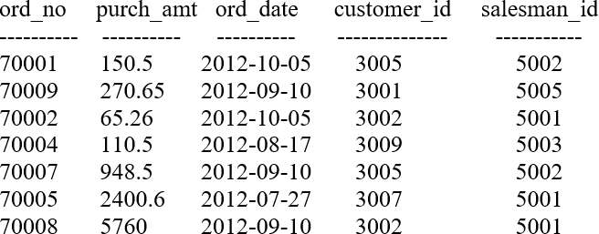

  - Select ord_no,salesman_id from sales where month(ord_date)=10;
  - Select customer_id, right(ord_date,2) from sales where salesman_id>5003;
  - Select length(monthname(ord_date)) from sales where customer_id=3005;
- Refer the table given below and write the Python code to create a DataFrame ‘classes’ 3
using nested lists for its values.
 | Test1 | Test2 | Test3 | Total
Alpha | 67 | 78 | 77 | 222
Beta | 78 | 78 | 89 | 245
Gamma | 68 | 80 | 87 | 235
- Consider the DataFrame ‘exam’ and write suitable Python statements for the 3
following questions:

 | Name | Score | Attempts | Qualify
A | Anasthasia | 12.5 | 1 | yes
B | Dema | 9 | 3 | no
C | Catherine | 16.5 | 2 | yes
D | James | Nan | 3 | no
E | Emily | 9 | 2 | no

  - Add a column called Result with the following data: [Pass,Fail,Pass,Fail,Fail].

  - Add a row at index F having following data :
[Name-sheldon, Score -10.0, Attempts- 1, Qualify-yes, Result-pass].
  - Remove the row at index C.
- Mr. Rajesh is an entrepreneur. He created a personal profile on social media platform 3
and set all that information to be viewed by public. After few days, he came across a different profile page with his personal information (such as name, date of birth, profile picture etc) claiming to be Mr Rajesh. A message was sent from this profile to the people in his friend-list requesting online fund transfer.
  - Mr. Rajesh is a victim of?
  - What immediate action should he take to handle it?
  - What can he do in future to safeguard his information?

OR
What is a digital footprint? List the types of digital footprints. Quote a real-life example for each type of digital footprint.
- Based on table CD given here, write suitable SQL queries for the following: 3

Table : CD
Code | Title | Duration_in_mins | Singer | Category
101 | Sufi | 50 | Shyam | 12
102 | Arabic | 45 | Zaki | 12
103 | Nagme | 25 | Sony | 70
104 | Dosti | 35 | Bobby | 45

  - Display the maximum duration of a CD as ‘Play time’.
  - Display the number of CDs category-wise.
  - Display the average duration of category 12 CDs.

OR
Discuss the difference between where and having clauses with a query each.

SECTION-D
- Write suitable SQL query for the following: 5
  - Display 3 characters starting from 3rd character in the string ‘all are welcome’.
  - Display the string ‘informatics practices’ in upper case.
  - Round off the value 143823.778 to 2 decimal places to the left of decimal.
  - Display 125 raised to the power 2.
  - Remove the spaces from both ends of the values present in the column first_name of the table class.

OR
Explain the following SQL functions using a sample query each.
- LOWER()
- LTRIM()
- MOD()
- SYSDATE()
- SQRT()
- ABC University is setting up its academic blocks at Naya Raipur and is planning to set 5
up a network. The University has 3 academic blocks and one Human Resource Center as shown in the diagram:

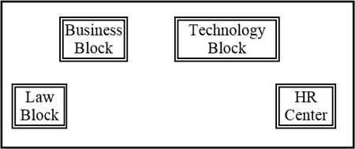
Distances between various blocks/center is as follows:
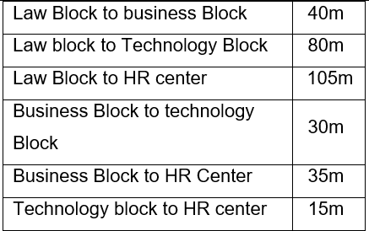
Number of computers in each of the blocks/center is as follows:
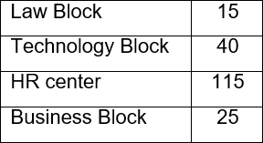
Based on the given information, answer the questions that follow:
- Suggest the most suitable place (i.e., Block/Center) to install the server of this University with a suitable reason.
- Draw the topology suitable for this network that is more efficient.
- Suggest the placement of a Repeater and Hub/Switch in the network with justification.
- The university is planning to connect its admission office in a place which is more than 1250km from university. Which type of network out of LAN, MAN, or WAN will be formed? Justify your answer.
- Name the protocol that can enable video-conferencing.
33. | Write a Python program to plot a bar chart based on the given data to depict the number of pages in 5 books.  Books=[CS,IP,AI,IT,C] Pages=[400,402,338,444,512]  Also give suitable Python statement to assign appropriate title, xlabel and save this chart.  OR  Write Python code to plot a line graph for Neymar’s goals scored against his opponents as shown in the figure: | 5

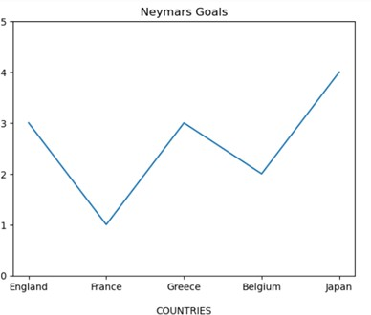

Also give suitable Python statement to assign appropriate title, xlabel and save this chart.
 | SECTION E
34. | Ms. Penny, a system administrator has designed a table TEACHER for a school. Help her by writing queries of the following questions based on the given table:  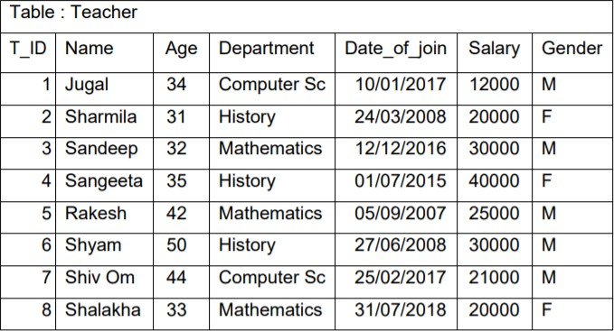  - Display the position of ‘a’ in the names of teachers from mathematics department in ascending order of their salary.  - Display the average salary of teachers who teach history.  - Display department and number of teachers in each department.  OR (Option for part iii only)  Display the departments having more than 2 number of teachers. | 1+1+2
35. | Mr. Howard, a data analyst has designed the DataFrame ‘ df ’ that contains data about his students and their marks scored in 3 subjects (IP,Eco and Eng) as columns and  indexes given as names of those students. Answer the following questions: | 1+1+2

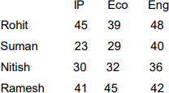
Dataframe df
- Predict the output of the following Python statement:
  - df.ndim
  - df.iloc[1:3,:]
- Write the Python statement to display the Marks scored by Rohit and Suman in IP. Assume that necessary modules are imported and the DataFrame df has been created.

OR (Option for part B only)
Write Python statement to create a new column named sum_of_marks which is the sum of marks scored in IP, Eco and Eng. Assume that necessary modules are imported and the DataFrame df has been created.

